RAJALAKSHMI ENGINEERING COLLEGE
(An Autonomous Institution)
RAJALAKSHMI NAGAR THANDALAM - 602105
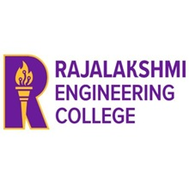

IT23731 CLOUD AND BIG DATA ARCHITECTURE
LABORATORY RECORD NOTEBOOK

REGISTER NO. : 2116231501053
NAME : GOKULAKKANNAN P
YEAR/ SEMESTER: VI/VII
DEPARTMENT : ARTIFICIAL INTELLIGENCE AND MACHINE LEARNING
ACADEMIC YEAR: 2026-2027

RAJALAKSHMI ENGINEERING COLLEGE
(An Autonomous Institution)
RAJALAKSHMI NAGAR THANDALAM - 602105

BONAFIDE CERTIFICATE

NAME: GOKULAKKANNAN P BRANCH: AIML
ACADEMIC YEAR: 2026 – 2027 SEMESTER: IV
2116231501053
REGISTER NO.:

Certified that this is a Bonafide record of work done by the above student in the IT23731 CLOUD AND BIG DATA ARCHITECTURE during the year 2026-2027.

Signature of the Faculty In-charge

Submitted for the Practical Examination Held on: ………………………..

Internal Examiner External Examiner

INDEX

Ex. No | Date | Name of the Experiment | GITHUB QR | STAFF SIGN
1 | 01/07/2026 | Installation of VirtualBox and Creation of Virtual Machines with Different Operating System Flavors | 
2 | 02/07/2026 | Installation of a C Compiler in the Virtual Machine and Execution of Simple C Programs | 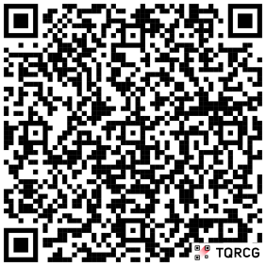
3 | 08/07/2026 | Installation of Google App Engine SDK and Development of Hello World and Simple Web Applications using Python | 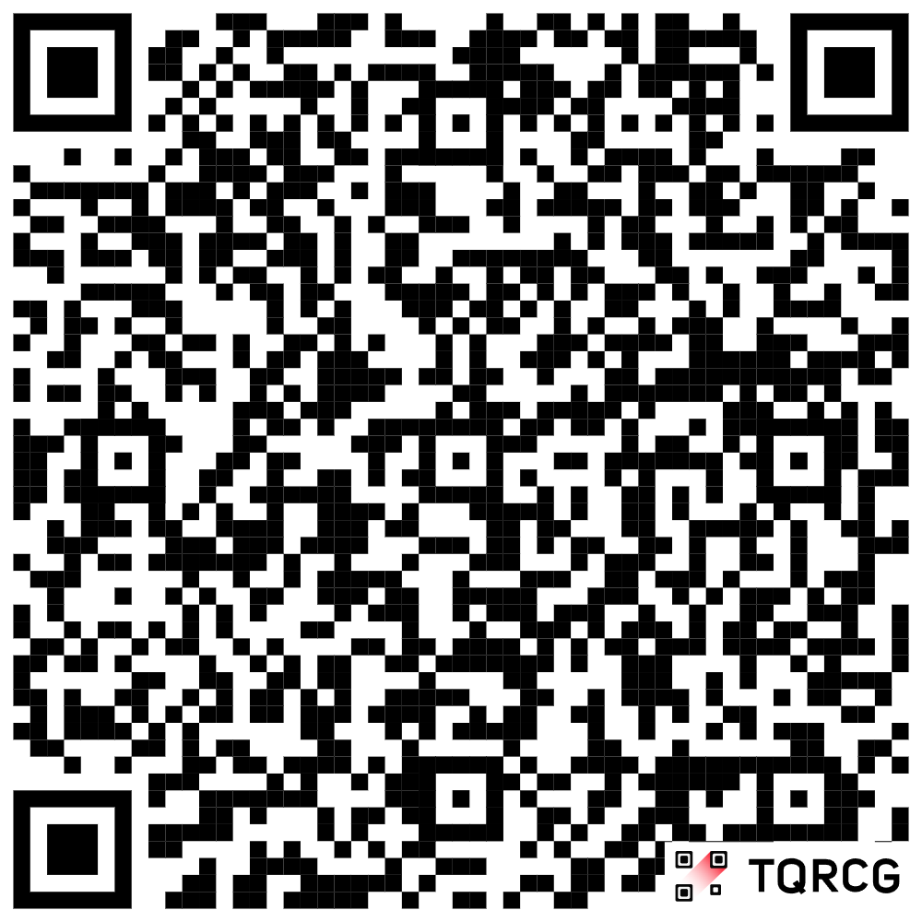
4 | 15/07/2026 | Use of the App Engine Launcher Tools to Launch the Web Applications
5 | 29/07/2026 | Develop a Python-based application that interacts with a local MinIO server (an Amazon S3-compatible cloud storage emulator) to understand the core concepts of object storage architecture, including buckets, unique object keys, and metadata tracking. | 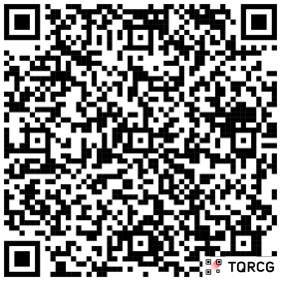
6 | 05/08/2026 | Simulation of a Cloud Scenario using CloudSim and Implementation of a Scheduling Algorithm Not Present in CloudSim | 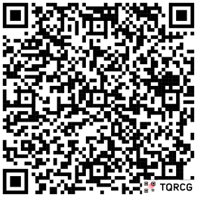
7 | 26/08/2026 | Procedure to Transfer Files from One Virtual Machine to Another Virtual Machine | 